©Sneed B. Collard III

Study Guide for Birds of Every Color
(Bucking Horse Books, 2019)

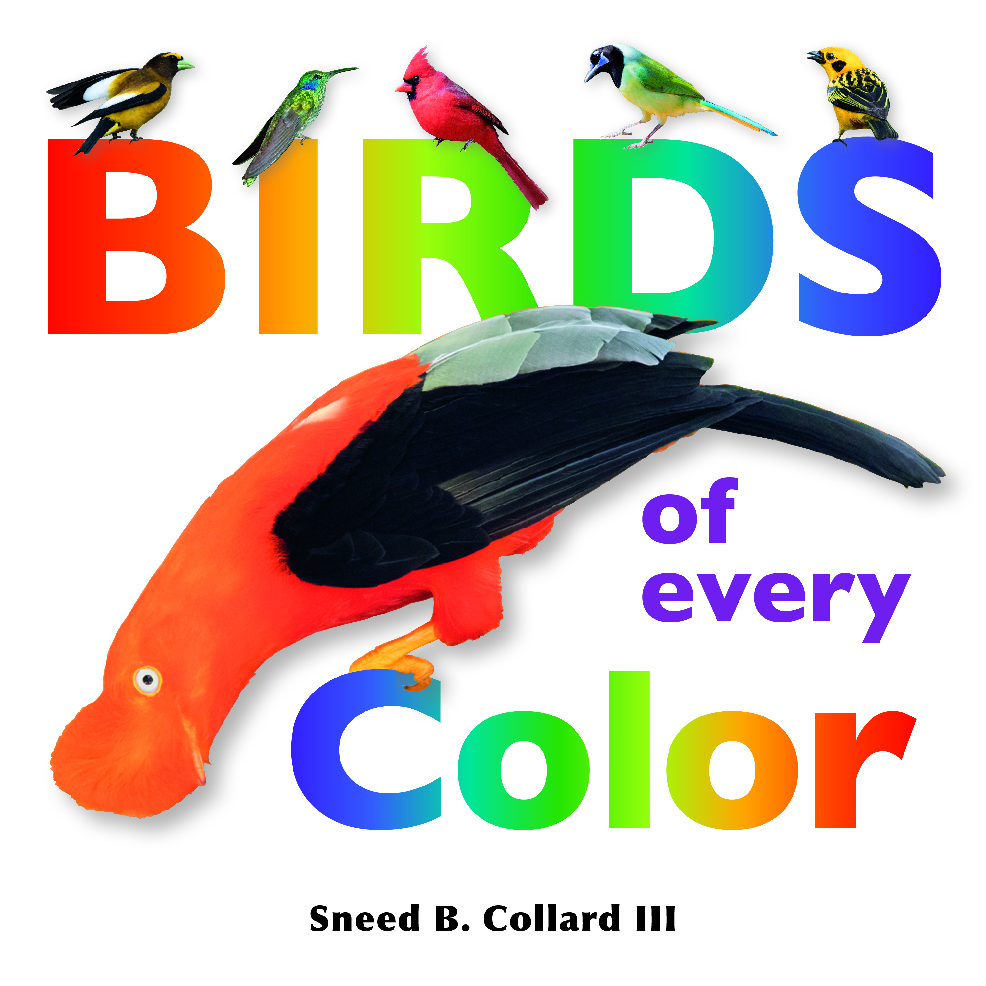
Book Description: Birds of Every Color takes a whimsical, yet scientific, look at the wonder, diversity, creation, and roles of colors in birds. Large, storytelling text appeals to young readers and to teachers and parents for reading aloud. Smaller, explanatory text allows older readers and adults to discover more of the science behind birds’ spectacular coloration. Stunning photographs by the author and his son help teach and entertain readers and teachers alike. Pre-K through grade 4.

Sharing the Book: Birds of Every Color is best read aloud to an entire class. The main “big” text forms a continuous nonfiction storyline, so the ideal way to share it is to read the big text all the way through without stopping. Then, go back and share the book page by page, stopping on each bird or spread. Read the explanatory “little” text and then invite questions and discussion from the class. Below are some questions you may want to ask your class on various pages or spreads.

Sample Classroom Exploration Questions for each bird and spread:
* Has anyone ever seen a bird like this? Where and what was it doing?
* Which colors do you see on this bird? Did the author talk about all of those colors, or did he save some? Why do you think he did that? (Hint: so kids could do their own research)
* How do you think this bird got its colors? Did the author give you any clues or information?
* How do you think this bird’s colors help it to survive?
* Are there any ways this bird’s colors might put it in danger? How?
* Can this bird hide its colors? How?
* What can you tell about where this bird lives from the colors it has?
* How do you think the author and his son got close enough to these birds to take the pictures? Did they use their phone cameras or do you think they had special cameras and lenses?
* What is your favorite bird in the book and why?
* Name some of the most colorful groups of birds that you learned about in this book.
* What are some of the new words you learned from this book? Which is your favorite and why?

ENGLISH LANGUAGE ACQUISITION

Activity #1 : What’s in a Name? (K-2)
Learning Objective: To flex creative writing muscles while making the connection that people are very much a part of science.
Learning Standard: Reading (Integration of Knowledge & Ideas); Speaking & Listening (Presentation of Knowledge & Ideas)
Materials: Copy of Birds of Every Color
Time Allotment: 1 hour
1) Read Birds of Every Color aloud, emphasizing the name of each bird.
2) Have each student pick one or more birds and think about their names.
3) Have the student decide about whether these names are the best names possible and, if not, pick new names that better describe each bird.
4) Using Birds of Every Color, have each student share a bird that she renamed with the class and explain why/how she chose that name.

Activity #2 : Bird Acrostic Poem (K-3)
Learning Objective: To practice research and writing skills by coming up with an acrostic poem that describes one of the birds in Birds of Every Color.
Learning Standard: Reading (Key Ideas & Details; Integration of Knowledge & Ideas; Craft & Structure); Speaking & Listening (Presentation of Knowledge & Ideas)
Materials: Copy of Birds of Every Color, standard research resources (books, magazines, computers with internet)
Time Allotment: 2 hours
1) Read Birds of Every Color aloud.
2) Have each student choose one bird and write its basic common name vertically on a piece of paper, i.e. “Summer Tanager” can be shortened to “Tanager.”
3) Have the student do research to learn more about his bird.
4) With research in hand, have the student write an acrostic poem that reflects features or aspects of the bird.
5) While another student or the teacher holds up the bird’s photograph, have the student read his poem aloud and or write it on a board.

Activity #3 : Colorful Biography (1-4)
Learning Objective: To promote word choice by having students write about themselves with colorful words.
Learning Standard: Writing (Text Types & Purposes)
Materials: Copy of Birds of Every Color
Time Allotment: 1 hour
1) Show how the author colored certain words in the “About the Author” and “About the Photographs” sections of Birds of Every Color.
2) Have each student write a paragraph about themselves or someone—including a pet—that she knows.
3) Have the students reread their paragraphs and then carefully choose words to color. For instance, if a student used the word “run” she might want to color that word blue; “angry” or “impatient” might get red or orange. EMPHASIZE THAT THE COLOR CHOICE SHOULD NOT BE RANDOM, BUT REFLECT EACH WORD SOMEHOW.

Activity #4 : Colorful Sentences (K-4)
Learning Objective: To build vocabulary and expression by using new words, or old words in new ways.
Learning Standard: Language Standards (Conventions; Vocabulary)
Materials: Copy of Birds of Every Color
Time Allotment: 30-60 minutes
1) Have kids review the glossary of Birds of Every Color or copy and hand this page out.
2) Have each student write a sentence using two or more words from the glossary—or other “colorful” words.
3) Share aloud in class, having the whole class listen for the colorful words.

ENGLISH/SCIENCE/ART

Activity #5: Compare and Contrast Bird Colors (K-2)
Learning Objective: To compare and contrast two birds from Birds of Every Color by creating a simple Venn diagram.
Learning Standard: Reading (Key Ideas & Details: Integration of Knowledge & Ideas)
Materials: Copy of Birds of Every Color, standard drawing/coloring materials
Time Allotment: 30-60 minutes +
1) Have students each choose two birds from Birds of Every Color.
2) Have each student make a list of all of the colors on that bird
3) Have students create Venn diagrams showing which colors the birds have in common and which are unique to that bird.
4) ADDITIONAL EXERCISE: Have students write a short paragraph of how each bird’s colors may indicate the environment it lives in based on earlier reading of Birds of Every Color.

Activity #6: Draw and Make Up Your Own Bird (2-4)
Learning Objective: Understanding that no animal lives in a vacuum. Every feature that it has is a product of how it survives in and interacts with its environment.
Learning Standard: Speaking & Listening (Presentation of Knowledge & Ideas); NGSS/Science (Interdependent Relationships in Ecosystems; Inheritance & Variations of Traits)
Materials: Pencil, paper, colored markers/crayons/paints; a copy of Birds of Every Color
Time Allotment: 2 hours
The author gave us a lot of ideas about how bird colors help them survive. Do the following:
1) Choose a made-up bird name
2) With a pencil, draw the outline only of your bird
3) Decide where your bird lives. Which continent? What kind of habitat (define this for your class if they don’t know this word)?
4) Think of a problem or challenge this bird might have. Does it have trouble attracting a mate? Do any other animals want to eat it? Which ones?
5) Based on your answers above, choose colors for your bird that will help it solve its problems and survive where it lives.
6) Using Birds of Every Color, figure out how your bird makes its colors. Does it get its colors from food? Does it create them in some other way?
7) Share your bird with the class. Tell everyone its name, where it lives, how it makes its colors, and how its colors help it to survive.

Activity #7: Observing Nature (2-4)
Learning Objective: Develop powers of observation and communication.
Learning Standard: NGSS/Science (Interdependent Relationships in Ecosystems; Inheritance & Variations of Traits); Scientific Method; Art
Materials: Notebooks, drawing materials, binoculars, magnifying glasses
Time Allotment: 1-2 hours
1) Explain how observation is an essential aspect of the scientific method, and how drawing something actually helps you to know it better.
2) In a nearby park or natural area, take students for a “slow walk”, encouraging them to stop and notice birds, mammals, plants, and other living things.
3) Encourage students to draw a plant or animal that they see.
4) Have students make a list of things they learned about this organism by drawing it.

SCIENCE/RESEARCH/WRITING

Activity #8: Learning More and Writing about a Bird (2-4)
Learning Objective: Using curiosity to guide research and writing about a topic; honing research and writing skills.
Learning Standard: Reading (all); Writing (Text Types & Purposes; Research to Build & Present Knowledge)
Materials: Pencil, paper, computers with internet connections, library with science books, copy of Birds of Every Color
Time Allotment: three to four one-hour sessions
1) Pick your favorite bird from Birds of Every Color.
2) Read what the author told you about this bird.
3) Make a list of other questions you have about this bird.
4) Do more research on this bird, either by reading other books or looking the bird up online. Suggested websites:
Birds of North America: https://birdsna.org/Species-Account/bna/home
Audubon Guide to North American Birds: https://www.audubon.org/bird-guide
Neotropical Birds: https://neotropical.birds.cornell.edu/Species-Account/nb/home
5) Pick five things you found interesting about your bird, and write a short paragraph including those five things. Think about the order you wish to share this information. Will the order make any difference to the reader?
OR
6) Making your bird the main character, write a fictional story about your bird. Use what you have learned to make your story as believable as possible. Feel free to include other characters and give it an exciting plot!

Activity #9: Holy Carotenoids! Picking a Color Superpower! (2-4)
Learning Objective: To understand where animal colors come from and how they are used; to practice creative writing
Learning Standard: Reading (Key Ideas & Details: Integration of Knowledge & Ideas); Writing (Text Types & Purposes; Research to Build & Present Knowledge)
Materials: writing tools
Time Allotment: 30-60 minutes
1) Ask your class to pretend that each one of them has a superpower. That power is that they can make themselves a single color whenever they want to. (Assume their clothes will also turn that color.)
2) Now have them write a story in which their superpower comes into play. The only catch? They have to know how their bodies make the superpower and think of a time when their superpower won’t work. For instance, if one student’s superpower is to turn orange, that student must understand that she has to keep eating foods with carotenoid pigments to keep turning orange. Encourage them to come up with a story in which they need their superpower, but it suddenly stops working and they must get it back again!
“Holy Carotenoids, Orange Girl!”

SCIENTIFIC METHOD, OBSERVATION, MATHEMATICS

Activity #10: Does Camouflage Work? (3-6)
Learning Objective: To test the effectiveness of animal design and apply the results to the world around you.
Learning Standard: Speaking & Listening (Presentation of Knowledge & Ideas); NGSS/Science (Interdependent Relationships in Ecosystems; Inheritance & Variations of Traits); Scientific Method; Data Analysis
Materials: Sets of marbles of at least three different colors (red, green, blue), notebooks and pencils, stopwatch, chart paper to create a bar chart or graph
Time Allotment: 1-2 hours
1) Pick a place on the ground to conduct an experiment. A green lawn works best, but you can also use a brown shag carpet, etc… . The important thing is that the experimental area must be all the same color.
2) Mark out a 1-meter or 1-yard square and outline it in some way.
3) Assemble at least three different colors of marbles or M&Ms or other small objects. Make sure one of the colors is similar to the color of your experimental area. Have at least 20 or 25 marbles of each color. (more might even work better) Green, red, blue, and yellow marbles work best.
4) Divide your kids into teams of 2 to 4.
5) While your kids are not looking, randomly spread all the marbles out into your study area.
6) When you say “Go!” give each team 15 or 30 seconds (figure out which time works best) to collect as many marbles as possible from the study area. REPEAT FOR EACH MEMBER OF THE TEAM, RECORDING THE RESULTS FOR EACH ROUND.
7) Have the team tally how many marbles of each color they found.
8) When all the teams have gone, have each team write a paragraph summarizing their results and giving hypotheses (possible reasons) for them.
9) As a class, tabulate all of the results into a bar chart or graph. Discuss your findings.
10) Based on these results, is camouflage an effective way to avoid being seen? What else did students learn?

SOCIAL STUDIES

Activity #11: COLORS ACROSS CONTINENTS (2-4)
Learning Objective: To connect bird colors across many continents and cultures.
Learning Standard: Social Studies/Geography
Materials: Copies of world map outlines for each student; writing and drawing material
Time Allotment: 1-2 hours
1) Ask the class if they think every continent is home to birds of every color.
2) Individually or in groups, have students choose a color and, using books and the internet, find a bird of that color for every continent.
3) Ask the students to write a short paragraph about what they learned from this exercise. Did they have trouble finding certain colors on certain continents?

OTHER USEFUL, WIDELY-AVAILABLE BIRD BOOKS
Beaks! by Sneed B. Collard III (Charlesbridge Publishing, 2002)
Feathers: Not Just for Flying by Melissa Stewart (Charlesbridge Publishing, 2014)
Warbler Wave by April Pulley Sayre (Beach Lane, 2018)
Woodpeckers: Drilling Holes & Bagging Bugs by Sneed B. Collard III (Bucking Horse Books, 2018)
Superlative Birds by Leslie Bulion (Peachtree Publishing, 2019)
Audubon's Birds of America: The Audubon Society Baby Elephant Folio by Roger Tory Peterson et al. (Abbeville Press, 2003)
* Don’t forget to look at birding guides, too !

ONLINE RESOURCES
The Cornell Lab of Ornithology website “All About Birds”: https://www.allaboutbirds.org/
The Audubon Society’s online guide to birds: https://www.audubon.org/bird-guide
Sneed’s and Braden’s father-son birding blog: www.fathersonbirding.com
Birds of North America: https://birdsna.org/Species-Account/bna/home
Neotropical Birds: https://neotropical.birds.cornell.edu/Species-Account/nb/home

A SPECIAL THANK YOU TO ELEMENTARY TEACHER KILA JARVIS OF RATTLESNAKE ELEMENTARY FOR HELPING TO CREATE THIS LESSON GUIDE!

To learn more about Sneed’s books, professional development workshops, and school visits, visit his website, www.sneedbcollardiii.com or contact him directly at collard@bigsky.net.

